“I can list” cards: Money

Penny. 1 Cent. Front-> 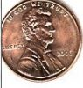 Back->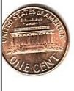= 1 cent

Nickel. 5 Cent. Front ->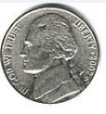 Back -> 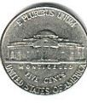= 5 cent

Dime. 10 cent. Front -> 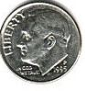 Back -> 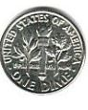 = 10 cent

Quarter. 25 Cent. Front->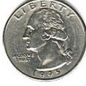 Back -> 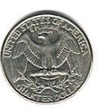= 25 cent

+ += 25 cent
10 cent + 10 cent + 5 cent = 25 cent

Quarter +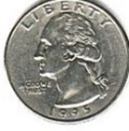++= 1 dollar/ 100 cent

Dime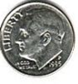+++= 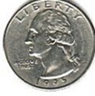 50 Cent
10 cent + 10 cent + 10 cent + 10 cent= 50 cents

Nickel 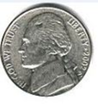+ = 10 cents
5cents + 5cents = 10 cents or 1 Dime

Penny 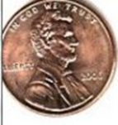+ ++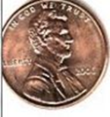+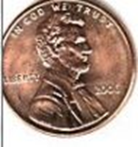=
1 cent + 1 cent + 1 cent + 1 cent + 1 cent = 5 cent or 1 Nickel

