Basic Addition Game
Kids Directions:
- Each player randomly lines their cubes along the plank, aligning them with the numbers written on the plank
- Player 1 rolls the number cubes/dice and adds them together and then removes the OTHER player's cube next to that number
- Player 2 does the same
- Players take turns adding together their numbers and removing the OTHER player's cubes
- When adding dice together, write down on the "game record sheet" the math problems you are solving.
- The first player to collect all of the other player's cubes is the winner!
- After you have done this game one time. Take out the “Apple Addition Sums to 18” worksheet and complete individually.
Example:
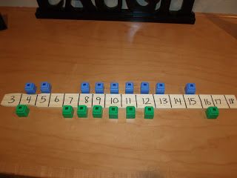
*Challenge Differentiation: Place cubes only even numbers. Players can only take away another players cube if they land on an even number where their opponent has a cube. This way kids have to practice their knowledge of even numbers.

