Time! Time! Time! Game!
Kid Directions:
- Set the timer for 7 minutes and take turns calling out Math Talk Cards to each other.

- Show your answers to the “Math Talk Cards” by drawing them with a dry erase marker on both sides of your paddle clock. Clear off your answer with a "Wet One" between each question.

- Do all the problems on both clock worksheets and turn in when finished.

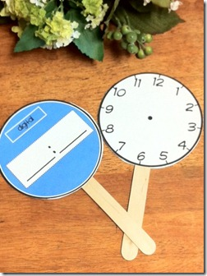

*Challenge/ Differentiation: Students will make a weekend schedule for themselves for Saturday. Starting at 7 a.m. They have to fit in 12 activities before 3 p.m. Each activity must be at least 30 minutes. On a piece of paper, write down your schedule with twelve different activities, record the time signature and how long each activity lasts.

